**First Person Shooter Game Development Company**

PUBG, Call of Duty, Modern Combat 5, NOVA Legacy, and many more First Person Shooters have been proven highly engaging and addictive for the young generation and hence leading towards the high revenue generation and success patterns for the gaming genre. These games are based on guns, weapons, and other shooting and fighting objectives and provide various actions and adventures to enhance mind distraction and refreshment.

These games are energetic with various controls involved to enhance the gameplay and it started with Maze War in 1973, and Spasim in 1974. This game features from the eyes of the player character and thus enhancing the adventurous experience. Various squad formations and fighting modes are blended together in various stages of these games that provide immense pleasure and energize the gamers. From history to the present day, the game has many releases with high revenue generation.

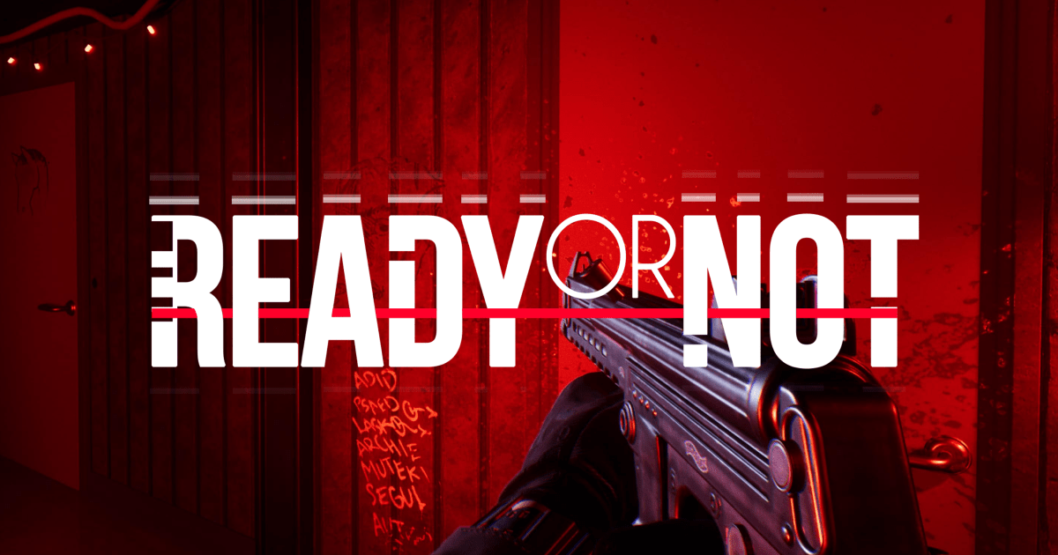

**First Person shooter gaming modes:**

Various gaming modes provide extensive features and animations from survival techniques to destroying ones that enhance the gaming experience for the pro gamers. Variant control systems and action variance are possible over the First Shooter gaming modes. 5 best modes that provide wide-spread fan base and user engagement with revenue generation for these First Person shooter games are:

* **Team Survival:**This mode is extensively represented in the blockbuster gaming applications like Gears of wars and Ghost Recon. This gaming mode works in a multi-player technique when two teams of gamers fight each other and try to wipe away their opponents. This technique provides hard competition with only one life available for each to survive and win.

* **Team Deathmatch:**This mode is at its best in the First Person shooting games like Halo, Quake, and Unreal Tournament. Team Survival and Team Deathmatch are almost the same playing techniques with only one difference of having unlimited lives in Team Deathmatch, unlike the prior one. These games reach their end with tougher competitions and with every kill being a significant step for the winning. Team Deathmatch is better than the Team survival but lacks from the others in terms of its in-effectiveness in slower games.

* **King of the Hill:**King of the Hill is a successful and admired gaming mode that is available for slower-paced games. This technique requires much knowledge, skills, and playing strategies for the teams to ensure one of the players sticking to the ground. These games are best suited for professional players and gaming competitions. This First Person shooting technique is available in top titles like Call of Duty: Black Ops 2 and Halo.

* **Capture the flag:**Capture the Flag has its wide reach and satisfactory playing available from Halo to Call of Duty and to Quake. This gaming technique has maintained its trend from many past years and is expected to exhibit the same pattern in the future too. This concept of capturing the flag is unique and provides excitement and fast-paced force and thus has maintained various Esports hits.

* **Search and Destroy:**Search and Destroy has a similar concept like Team survival, it differs in boosting up some specific objective. Teams attack the bomb sites and survive the attacks with only one life to win. It involves planting and defusing the bombs to play the game with various adventures. Counter-Strike and Call of Duty have been successful due to the use of this machine in the gaming technique.

**First Person shooter game designs:**

The mobile First Person shooting games have various features and realistic experience with 3D experience blended with perfect soundtracks and qualities and the game controls. The game views generally exhibit the player’s body with weapons and the maps showing the pathway along with the nearby surrounding. Let us have a look at the few designs that are effective for this development:

* **Combat and power-ups:**Some games use melee combat and melee weapons in the enemy’s close proximity to fight and earn the rewards. These require more strategies and teamwork to win. These games use a variety of fighting weapons from pistols to grenades and rifles and even include imaginative enemies like aliens and monsters to enhance the adventurous experiences. Various rewards and power-ups are also provided with every killing in the gameplay.

* **Level Design:**The First Person shooter gaming designs also work with various new features and specifics from beginner to advance level as one moves forward in the gameplay. Various puzzle solving and environmental destructions can also be caused by varying difficulties in the gaming arena.

* **Multiplayer:**Multiplayer technique can be involved in these games like PUBG and Call of Duty has. This multi-playing enhances the gaming experience with the massive involvement of various folks in a single gameplay. Different people compete with each other and fight till their last breadths in the game to survive and have the prize. PUBG even has a trend of ‘Winner Winner Chicken Dinner’ that attracts an extensive amount of folks.

* **Free to play:**Free playing is always widely promoted for maximum user involvement in the game. With this technique involved in First Person Shooter, gameplay becomes popular and widely recommended with the ease provided for the players.

**Monetization techniques:**

Monetization is the most crucial and prior agenda in a game release. To earn maximum profit from First Person shooter games, there are various game monetization techniques available, like:

* **In-App purchases:**These game uses Freemium techniques i.e., free games that have some in-app purchases to enhance the gaming experiences with the added features. They provide enhanced activities to the gamers and hence are successful in monetization along with maintaining the user-base.

* **Ad-supported games:** These games benefit from displaying various Ads for different companies and their applications. Also, with each visit or download made from those advertisements, bonus earnings are provided too for the game publishers.

* **Hybrid models:**These games use both the above techniques of in-app purchases as well as the Advertisements to get better earnings from the blended monetization.

**Game Development Company:**

Game App Studio provides the best First Person shooter game development with the best gaming modes and designs to ensure maximum revenue generations. Game App Studio excels in the development due to the following facts:

1. Team of experts having experience of 7+ years.
2. Best marketing techniques provided with monetization and budget management.
3. 24/7 availability for the clients.
4. Best quality and resolutions provided for the game design with attractive UI and UX.
5. Prototype developments and testing until the success title identified.
6. App Store Optimization for developed products.